Overview of commands to interact with DLP reader and RFID tags (TI HI-plus)

# Interacting with the Reader

The DLP reader has a host protocol depicted in Figure 1.

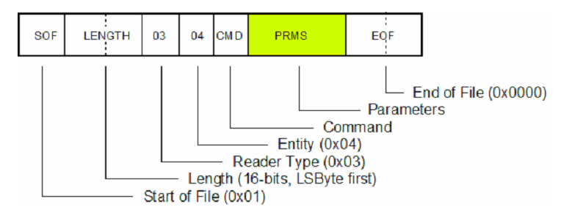

Figure :DLP host protocol

The protocol begins with a 0x01 (Start Of File) byte, then 2-bytes for the length of the command, sent Least Significant Byte first. The length specifies the total number of bytes sent, including the SOF and EOF bytes. Bytes 5 and 6 are always 0x03 and 0x04 respectively and they are followed by a command byte. There are THREE basic commands we can use (see Figure 2).

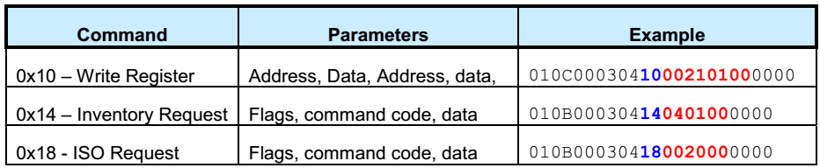

Figure :Basic RFID tag commands

Communication with the RFID tags uses the ISO15693 protocol commands. To use these commands, the ISO request command is passed to the DLP reader and the parameters are the actual ISO15693 command. The ISO15693 commands have the form shown in Figure 3. Only the flags, command, and parameters are used by the DLP module wrapper.



Figure :ISO15693 command form

# Configuring DLP reader

To set up the DLP reader, the Write Register (0x10) command must be sent to the module. The specific commands are:

|  |  |
| --- | --- |
| command | result |
| 010C00030410002101000000 | Writes to module register to use 1-of-4 modulation and full power |
|  |  |
|  |  |

# Tag Memory

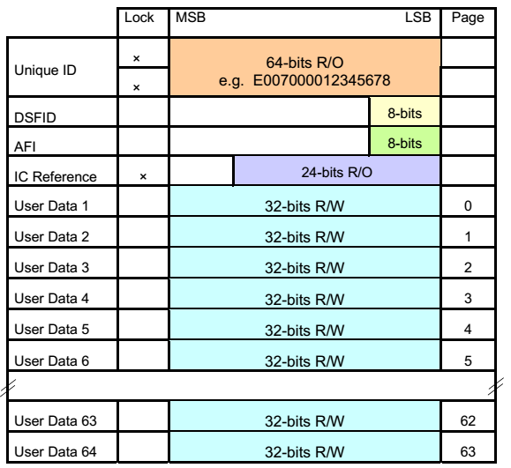

Figure : HF-I Plus memory map

* UID: Accessed using the Inventory command. Contains a unique address/serial number for individual tags. This can be used to address individual tags.
* DSFID (Data Structure Format Identifier): a location to write information about the User Memory structure
* AFI (Application Family Identifier): Field that allows tags to be classified into “family” groups:

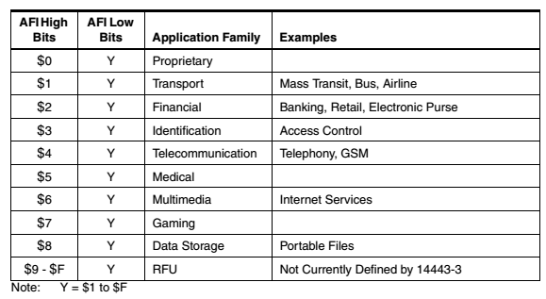

Figure :AFI Code Family Definitions

* IC Reference: read only information about the IC
* User Memory: 64 pages of 32-bit memory blocks. Each page can be read, programmed and locked

# The ISO15693 Protocol

* Addresses and data are sent LSB first
* Cards will respond to requests matching their UID, general (no UID given), or if in select mode
* See TRF7960EVM user guide section 3.5 for details on protocol and specifics for commands